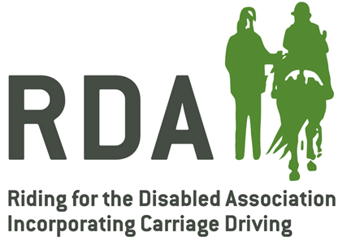

GROUP DATA PROTECTION
Woodchurch Driving Group RDA

- You have a right at any time to stop us from contacting you for marketing purposes.

- You have the right to request a copy of the information that we hold about you.

- We want to make sure that your personal information is accurate and up to date.

- You may ask us to correct or remove information you think is inaccurate.

Last updated 2022.

